If you are having problems with the appearance of this newsletter please follow this link.

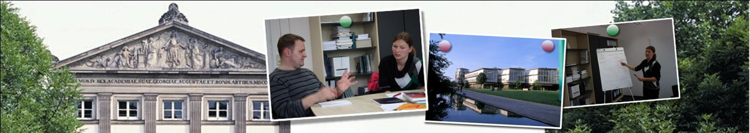
November 2013  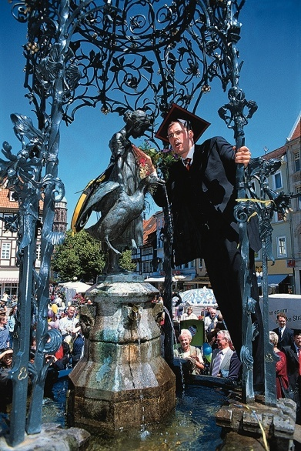  Content  Financial support offered by the Faculty of Social Sciences  Election of the PhD-spokesperson of the GGG  New courses for PhD-students 2014  Launch "CeMIS-CeMEAS Transregional Research Network (CETREN)"  Winter Semster 2013/14: "Modern Indian Studies Colloquium"  WBG scholarship for doctoral students    Contact  Martin Ertelt  Students Office of the  Faculty of Social Sciences  University of Goettingen  Phone +49 (0)551 39-19730  E-Mail Martin.Ertelt-1@sowi.uni-goettingen.de  Homepage http://www.uni-goettingen.de/en/40642.html | Dear doctoral students,  dear graduates,  with this newsletter in November we will inform you about proposals and events which might be of interest for your doctoral studies.  With kind regards from the Students Office of the Faculty of Social Sciences  Martin Ertelt  Financial support offered by the Faculty of Social Sciences  In 2013 the Faculty of Social Sciences supports additional courses and individual measures in the context of the PhD programme. Information about the requirements and application procedures can be found here. Additionally you can apply for allowance for action of internationalization. Further information can be found here.  Election of the PhD-spokesperson of the GGG  The new spokesperson of all PhD-students of GGG will be elected between 18 November and 4 December 2013 via online tool.  The access data is sent to you by email. All PhD students of the 5 member faculties as well as the students of the PhD programs accepted by the GGG are entitled to vote. If you as a member do not receive any email with access data between 18 and 20 November, please check your spam or get in touch with the GGG.  The PhD representation consists of a spokesperson and his/her deputy and is annually elected by the PhD students.  For further information about the elections please refer to the GGG website.  New courses for PhD-students 2014  For an overview of the courses for PhD students in 2014 offered by the GGG and cooperating institutions, please refer to www.qualiportal-promovierende.uni-goettingen.de. The annual printed course booklet for 2014 is sent to you in January and will then also be available online.  Launch "CeMIS-CeMEAS Transregional Research Network (CETREN)"  The "CeMIS-CeMEAS Transregional Research Network (CETREN)" is inviting to its official Launch Event at Paulinerkirche (Papendiek 14) on Friday, 6 December 2013 from 1:45 pm to 6:00 pm.  Funded by the German Ministry of Education and Research (BMBF), CETREN fosters exciting new collaborations between disciplines and area studies to produce innovative “place-based” knowledge in the social sciences and humanities. The Launch will showcase CETREN’s pilot project "The Politics of Secularism and the Emergence of New Religiosities." The event will feature talks by Prof John R. Bowen (Washington University, St. Louis), Prof Peter van der Veer (MPI MMG, Göttingen), Prof. Birgit Meyer (Universiteit Utrecht), and Prof William Gould (University of Leeds) as well as a photo exhibition on muslim urban quarters in Central Asia and Western China.  Winter Semster 2013/14: "Modern Indian Studies Colloquium"  In the winter semester, CeMIS will offer a colloquium for the presentation and discussion of current research projects. Starting in November 2013, the colloquium will usually meet on Wednesdays, 4-6 pm in Room No. 2.112 ("Board Room", Waldweg 26, northern wing). Here you will find a detailled programme.  WBG scholarship for doctoral students  The „WBG-Doktoranden-Stipendium 2014/2015“ for the support of early stage researchers provides a monthly allowance amounting to 900 € for two years.  Further information can be found here.
University of Goettingen – Faculty of Social Sciences

If you are no longer interested in receiving our newsletter, you can cancel it at any time. Please contact us by email
then. Please consider, however, that you no longer receive any doctoral-study-related information then. From that point on you would have to inform yourself on the faculty websites. If you want to change your email-address please contact us.

